Beta-binomial distribution

Def

Parameter



Support



PDF

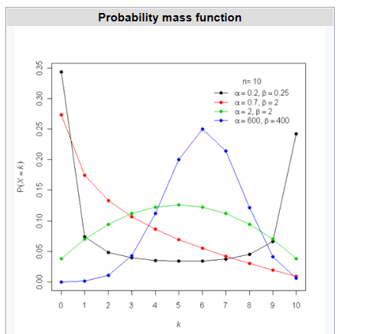

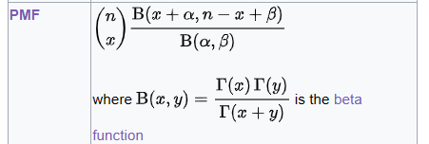

CDF

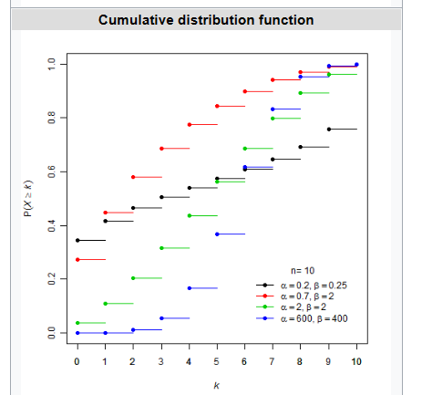

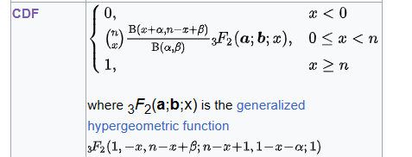

Expected Value



Variance



Skewness



Ex. Kurtosis



MGF



CF



PGF



Factorial Moment

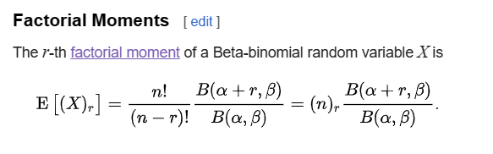

Ref

[Beta-binomial distribution - Wikipedia](https://en.wikipedia.org/wiki/Beta-binomial_distribution)